1. Link gốc https://en.nhandan.vn/lawmakers-propose-measures-to-boost-development-in-mountainous-border-regions-post168532.html

Lawmakers propose measures to boost development in mountainous, border regions
National Assembly (NA) deputies proposed measures to capitalise on regional strengths, strengthen connectivity and promote socio-economic development in midland, mountainous and border areas during discussions on the 2026 socio-economic development and state budget plans at the NA’s ongoing second session on October 31.
Saturday, October 31, 2026 at 18:26
NA deputy Doan Thi Le An from Cao Bang Province speaks at the discussion. (Photo: NDO)
They praised the Government, the Prime Minister and ministries, sectors and localities for their efforts, noting that despite numerous difficulties, Viet Nam has maintained high economic growth and basically stable macroeconomic conditions, creating a foundation for securing growth of at least 10% in 2027.
Improving livelihoods through forest protection
Deputy Ta Thi Yen from Dien Bien province highlighted the strategic importance of the northern midland and mountainous region in national defence, security safeguarding and upstream forest protection, while noting the hardships faced by local residents, particularly ethnic minority communities.
She said development policies should recognise their contributions and provide better livelihoods and incomes for people involved in forest protection.
While forest environmental service payments have delivered positive results, and the Government has introduced a policy on forest carbon absorption and storage services, she urged more effective implementation, assessment of real benefits for local communities and transparent management and use of revenues.
Such measures will improve living standards while protecting water resources and the ecological environment, she said.
Yen also pointed out that high transport costs, scattered production areas and shortages of cold storage facilities and logistics services are discouraging investment in agricultural processing and distribution.
She called for integrated transport infrastructure linking production areas with processing facilities, border gates and markets, alongside stronger incentives for businesses investing in agricultural processing, preservation and logistics in mountainous areas.
For the northern midland and mountainous region, it is necessary to continue capitalising on local advantages of agriculture, specialties, forestry, medicinal plants, processing industry, and tourism associated with natural landscapes and the cultural identity of ethnic minorities, the deputy added.
Preparing clean land for border-gate economic zones
Deputy Doan Thi Le An from Cao Bang province called for improved policies to develop the border-gate economy in mountainous and border areas, focusing on clean land preparation and investor selection.
She said international border gates such as Ta Lung and Tra Linh, together with the Dong Dang–Tra Linh expressway project, offer Cao Bang opportunities to expand trade with China and ASEAN. However, difficult terrain, limited land availability, high infrastructure costs and land and investment procedures remain major obstacles.
As suitable sites for logistics, warehousing and trade are often interspersed with agricultural, forestry and residential land, the preparation time for some projects can take 1.5–2 years while investors need ready-to-use premises, she noted.
An proposed that the Government consider submitting to the NA a pilot mechanism for preparing clean land in priority areas of border-gate economic zones, based on approved 1:2,000 zoning plans. She added that the mechanism should clearly define its scope, prioritise essential infrastructure, ensure adequate compensation and resettlement arrangements, and provide transparent oversight of land use and implementation.
She stressed that zoning plans must not replace legal requirements for land acquisition and that land preparation must protect residents’ livelihoods, particularly those of ethnic minority communities in border areas.
Regarding investor selection, the legislator suggested applying existing mechanisms under Articles 23 and 28 of the 2025 Investment Law while working out a mechanism to attract strategic investors to some logistics, warehousing and commercial projects with high spillover effects.
However, she cautioned against waiving land auctions and bidding procedures solely on the basis of registered investment capital of 500 billion VND (19.3 million USD) or more, saying this alone could not demonstrate an investor’s capacity or project effectiveness.
An called for clear selection criteria covering financial capacity, experience, disbursement commitments, job creation and contributions to local development, alongside transparent supervision and accountability.

2. The Kindness of Strangers: In 1989 I lost a wallet with $1,000 in it. A couple went to incredible lengths to return it
- Link gốc: https://www.theguardian.com/lifeandstyle/2026/nov/02/kindness-of-strangers-lost-wallet-cash-returned-couple

The kindness of strangers: In 1989 I lost a wallet with $1,000 in it. A couple went to incredible lengths to return it
Cash was king in those days, and that money was enough to last me for a month as I slowly travelled from Australia back to the UK


‘It wasn’t until the next morning that I realised the incredible lengths they had gone to in order to return my wallet.’ Composite: Victoria Hart/Guardian design/Getty Images

It was a hot night in 1989 when my wallet – stuffed with $1,000 cash – fell out of my pocket.
After university, I left the UK and went travelling in Australia for a year. I saw the delights of the east coast – mostly from various building sites, as I worked my way around doing long hours in the blistering sun. But I loved every minute of it. After 10 months, I had saved enough to make my way slowly back home.

I was enjoying one last night out in Darwin with a gang of traveller friends with whom I was flying to Timor the next day. The intention was to island hop all the way to Singapore.

Cash was king in those days, and the $1,000 I had in my wallet was enough to last me a month on the road. The beers went down easy and I was completely unaware when, at some point in the evening, I lost my wallet. I was still none the wiser when I went to bed to get some sleep before the flight the next morning.

At 1.30am, I awoke to a loud knocking on my door. I stumbled out of bed, bleary-eyed, and opened the door to the hostel manager and an elderly couple – who were holding my wallet.
That couple had spent hours trawling every backpacker place in Darwin (they’d been to four!) before eventually finding me, care of my student ID card. Every dollar was still there.

Still half asleep, and worse for wear after the evening’s drinks, I didn’t fully appreciate the extent of their kindness in the moment. I thanked them and went back to bed, but it wasn’t until the next morning that I realised the incredible lengths they had gone to in order to return my wallet. Without them, my trip would have been ruined.

I’ve always wished I could thank them properly, but in lieu of that I made a pledge to myself – and in a way, to them – that I would always go that extra mile to help people when I have the chance.
When I do get the opportunity to lend someone a hand, I always tell them to pay it forward. So I like to think that kind couple in Darwin have actually helped countless others, too.

3. A new start after 60: At 26, I saw my dream Porsche. At 68, I built one from scratch
- Link gốc: https://www.theguardian.com/lifeandstyle/2026/nov/02/a-new-start-after-60-at-26-i-saw-my-dream-porsche-at-68-i-built-one-from-scratch

A new start after 60

A new start after 60: At 26, I saw my dream Porsche. At 68, I built one from scratch
Bill Drysdale could never afford the sports car he fell in love with as a young man. So when he retired, he went to night school to learn welding, and began assembling it, bit by bit ...

vowed, “I will have one of those.” As the years went by, the price of Drysdale’s dream car rose above £1m. “I realised I was never going to be able to buy one.” But when he retired, still harbouring the dream, he thought: “Why don’t I make one?”



Drysdale grew up in Wigtown, Scotland, and cars were in his blood – his grandfather was chauffeur to the local creamery manager, and he first saw a race with his father, when he was 12 – around the time that his mother went into hospital with multiple sclerosis. Drysdale, an only child, grew close to his father. At 14, he taught him to drive. Together they’d huddle in the kitchen to listen to the Le Mans 24 Hour race on the radio.

Drysdale was only 21 when his dad died; his mother ended up staying in hospital for 23 years. “That made me very independent,” he says. Determined? “Pig-headed, some would say.”

After studying maths and physics at the University of Glasgow, he joined a brake manufacturer as a graduate apprentice engineer. “Oh, it was tremendous,” he says. “As young chaps in the company, there was always this interest in cars and racing and competition.” His favoured form was “sprinting – racing against the clock, competing against yourself”. It was while playing mechanic to a friend in the pit at Silverstone that he saw the Porsche 904 and was floored by “the sound, the look, the line”.

Drysdale married and became father to a son and a daughter, at which point he stopped motor racing. While his wife stayed at home in Warwickshire, England, he travelled widely for work – India, South Africa, Brazil, Japan, Argentina, Europe, Australia. By the time he retired at the age of 58, he was international president for a Canadian company, and moved back to Scotland. It was here that he had the idea to build his own version of the famous Porsche.

Drysdale went to night school for six months to learn how to weld. Through a friend of a friend of a friend, he got a blueprint of the original Porsche 904. He made the shape of the body in his garage, first from wood, then plaster of paris. From this he made fibreglass moulds; his wife, Lucia, helped him to make the resin. Next came the doors, a bonnet, front and rear wings, the interior and instrument panel.

“Once I had the body, I could concentrate on the engineering, fabricating the chassis, designing the suspension. That was all from scratch,” he says. He bought a secondhand engine and transmission – “then started to put all the parts together”.


Drysdale driving his ‘Porsche 904FF’. Photograph: Joy Richings
The children “thought I was off my rocker”, he says. Sometimes, the project would defeat him. “For a couple of months I would not go into the garage at all. Then the enthusiasm would come back … I’ve always been interested in broadening myself.” After eight years, the car was finished; Drysdale was 68. He calls his car a Porsche 904FF. The double Fs stand for “effing fake”.

When it was done, he transported the car to test days at race tracks, where he did laps to set up the handling. In Scotland, England, France and Switzerland, he competed in speed hill climbs and sprints, right until February this year, when at 87 a stroke affected his sight and put paid to driving.

“I’m coming to terms with it but it is very difficult,” he says. Meanwhile, the car continues to compete, driven by friends, while Drysdale takes part as “entrant”. He is already planning the next season. “I intend to be in the paddock, in the pit, next year with my race car, with someone else driving it.”

“I think my dad would have said: ‘Yep, that’s my son,’” he says. “The car has given me a dream. I’m a great believer that you must have a dream. A dream to me is something you really would like to do but don’t know if you ever will. That’s my philosophy in life. Look forward. And do the things that you want to do.”

4. Gánh mưu sinh:
https://e.vnexpress.net/news/travel/places/street-vendors-with-shoulder-pole-a-familiar-sight-in-vietnam-s-old-town-4099491.html

Street vendors with shoulder pole a familiar sight in Vietnam's old town
By Do Anh Vu, Huynh Phuong May 15, 2020 | 04:52 pm GMT+7
Get VnExpress first in Google Search
The bamboo shoulder pole with baskets filled with agricultural produce and other wares could well be the leitmotif of Hoi An.
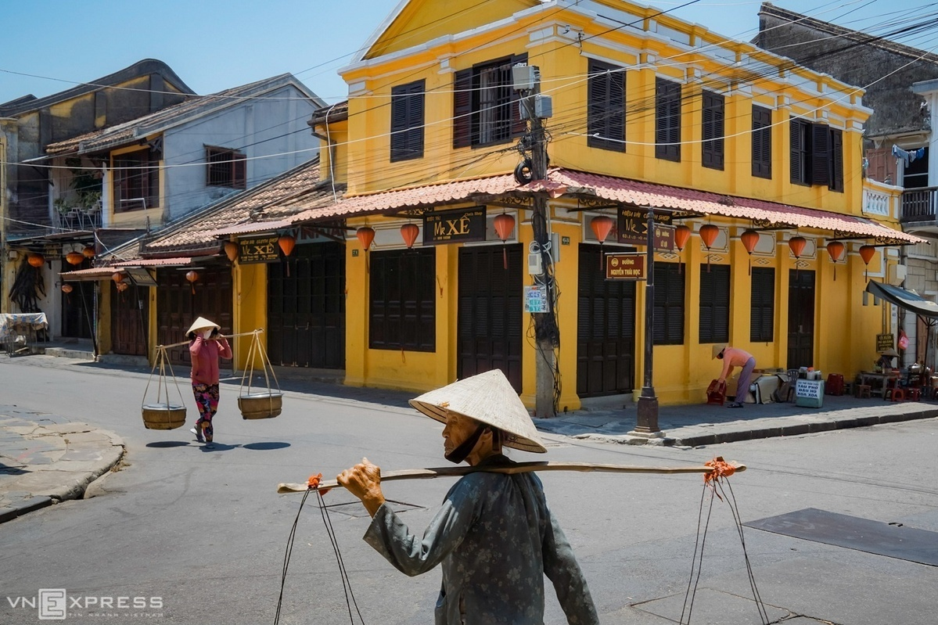
Two women with baskets on their shoulders at the intersection of Nguyen Thai Hoc and Le Loi streets. The photos by Do Anh Vu show the langorous pace of life in Hoi An, a popular tourist destination in central Vietnam.
The bamboo shoulder pole, quang ganh, has for long been a useful piece of equipment for Vietnamese farmers in the countryside to carry their produce and earn a living on the streets of cities, and is a familiar sight in the ancient town of Hoi An.


Chrysanthemum flowers sold on a sidewalk of Hoang Van Thu Street.

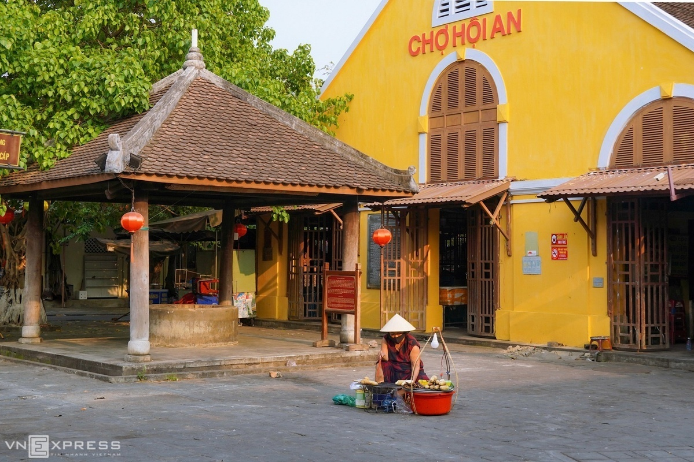
A woman sells grilled corn outside the deserted Hoi An Market. The picture was taken on April 6, when the country was in the midst of the social distancing campaign meant to contain the Covid-19 pandemic.

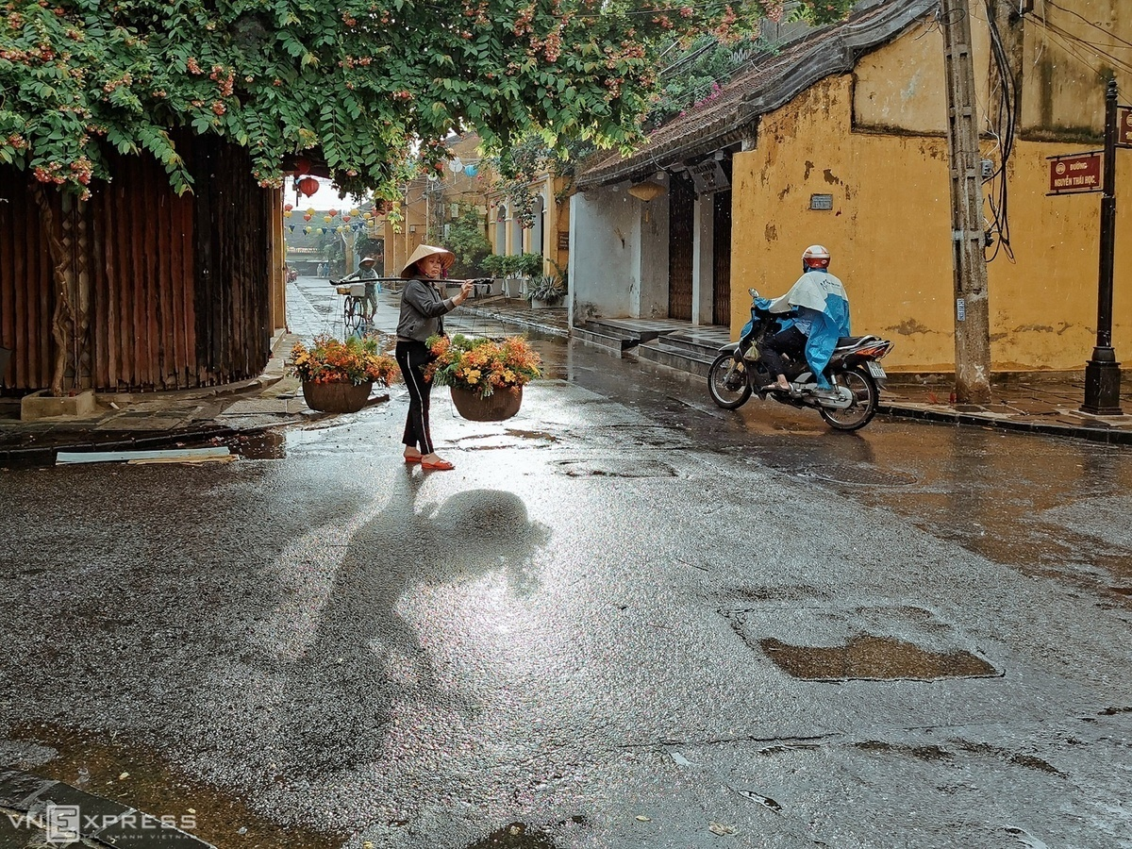
A woman carrying flowers walks in the rain at the junction of Hoang Van Thu and Nguyen Thai Hoc streets.


An old lady sells bananas on Bach Dang Street by the iconic Hoai River that flows through the town.


A woman with a basket of rice crackers walks past a Chinese-style house on Nguyen Thai Hoc Street.


On the town’s streets, visitors can often see women carrying a quang ganh on their shoulders and hawking their wares. They usually sell bananas, grilled corn, tofu, duckweed, pound cakes, and fresh flowers.

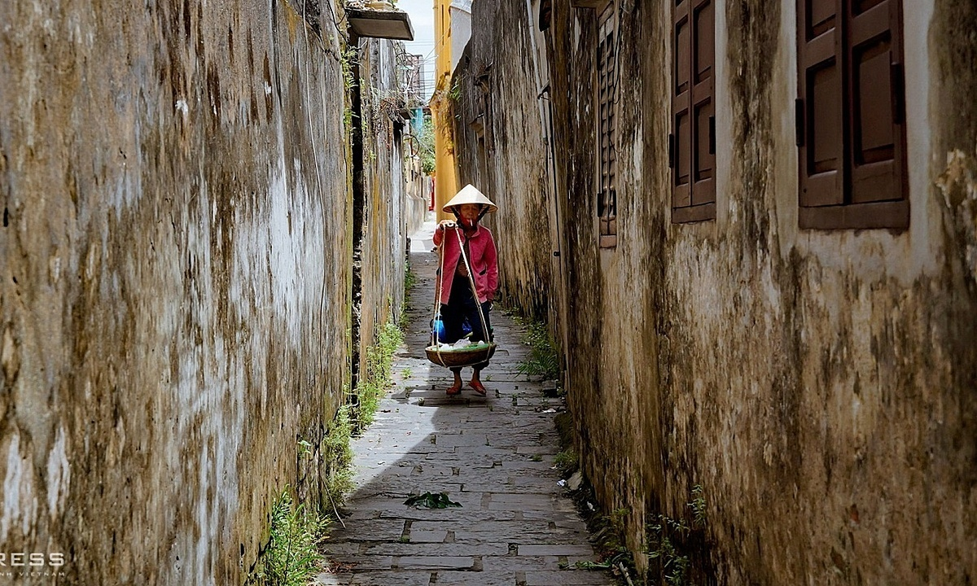
A woman with a quang ganh walks in a tiny moss-covered alley.

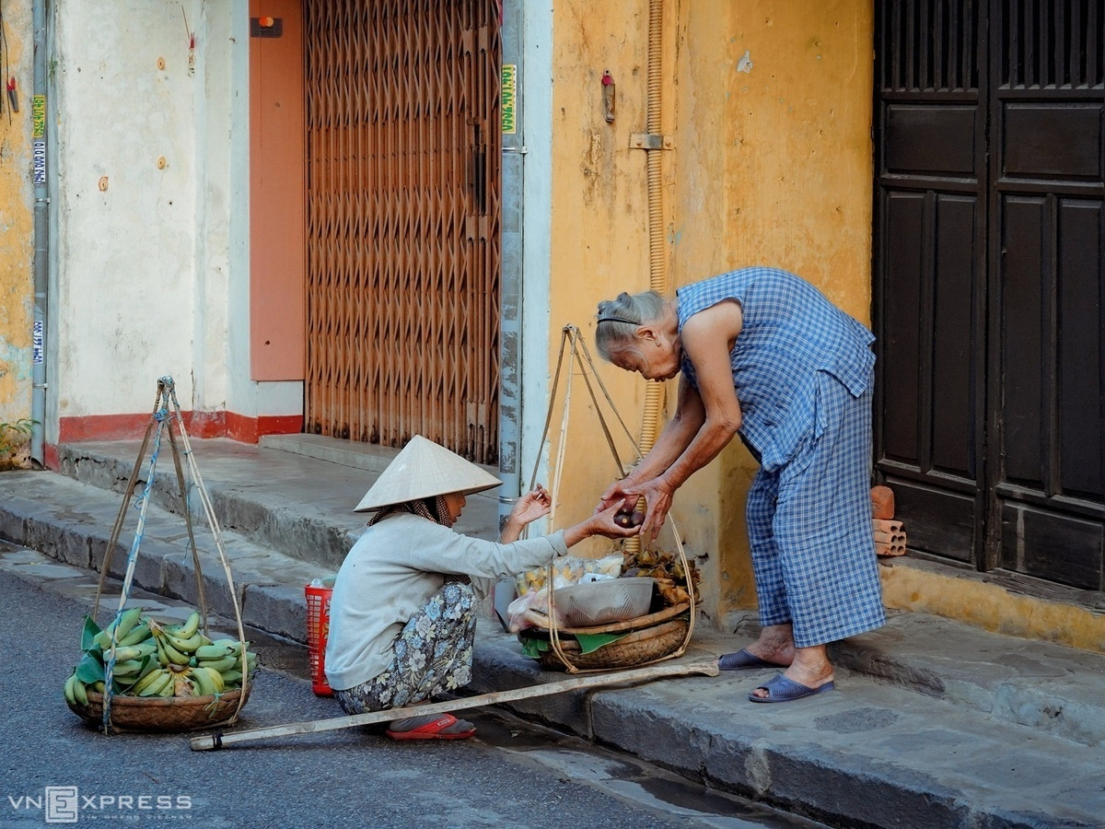
A hawker sells sweet potatoes on Tran Phu Street.

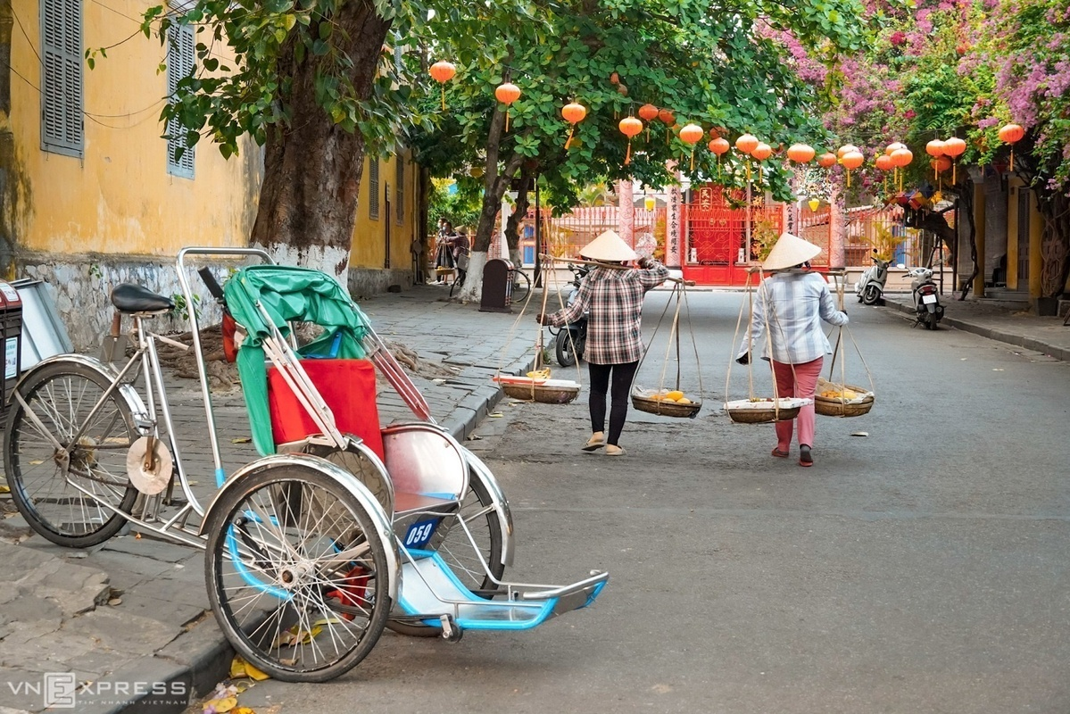
Two women carrying baskets of fruits walk along Chau Thuong Van Street.
Hoi An has been a pioneer of pedestrian-friendly streets in the country since 2004. Motorbikes and cars are banned from the town center from 9 a.m. to 11 a.m. and 3 p.m. to 9:30 p.m. Most hotels, restaurants and homestay facilities rent bicycles.

5. https://en.nhandan.vn/500-day-and-night-campaign-dna-testing-results-returned-for-nearly-800-samples-of-martyrs-remains-post167905.html

500-day-and-night campaign: DNA testing results returned for nearly 800 samples of martyrs’ remains
After seven months of the 500-day-and-night campaign, relevant units have completed DNA testing and returned results for nearly 800 samples of martyrs’ remains, successfully identifying dozens of fallen soldiers. Each result reflects the dedication and sense of responsibility of the participating forces, while bringing great comfort to the families of those who sacrificed their lives for the Fatherland.
Saturday, October 17, 2026 at 22:30
Ceremony marking the transfer of samples of martyrs’ remains collected from provinces and cities from an aircraft at Gia Lam Airport in Ha Noi on September 11, 2026, for handover and DNA testing. (Photo: THE DAI)
Bringing great comfort to families of fallen soldiers
Sharing information on the current situation and results of efforts to identify martyrs’ remains through DNA testing, Ngo Kieu Lien, Head of the Data and Information Division for People with Meritorious Services under the Department of People with Meritorious Services, Ministry of Home Affairs, said that searching for, collecting and identifying martyrs’ remains is an important and sacred political task that has consistently received attention and direction from the Party and State.
Under current regulations, the identification of martyrs’ remains is carried out using two methods: identification based on factual evidence and DNA testing. DNA testing has been implemented since 2013 under Project 150, approved by the Prime Minister through Decision No. 150/QD-TTg dated January 14, 2013, on identifying martyrs’ remains with missing information. In practice, this has proved to be a highly reliable scientific method, making an important contribution to restoring the identities of fallen soldiers.
As the 500-day-and-night campaign to accelerate the search for, collection and identification of martyrs’ remains is being implemented, ministries, sectors, localities and DNA testing units have worked closely together and made considerable efforts.
Specifically, during the first seven months of the campaign, from March 15 to October 15, 2026, relevant units completed DNA testing and returned results for nearly 800 samples of martyrs’ remains, successfully identifying dozens of fallen soldiers. The results have been respectfully delivered to their relatives.
Each result reflects the dedication and sense of responsibility of the participating forces, while bringing great comfort to the families of fallen soldiers.
An overview of Nhan Dan Newspaper’s online discussion, “Looking back at the achievements of more than 200 days and nights of efforts to bring fallen soldiers’ home”. (Photo: MINH DUY)
Lien shared this information during an online discussion entitled “Looking back at the achievements of more than 200 days and nights of efforts to bring fallen soldiers home”, organised by Nhan Dan Newspaper.
However, according to the head of the Data and Information Division for People with Meritorious Services, these results remain modest compared with the number of unidentified martyrs’ remains and the expectations of their relatives.This is mainly due to various objective difficulties, which relevant authorities are working together to address.
Under the assignment of the National Steering Committee for the Search, Collection and Identification of Martyrs’ Remains (National Steering Committee 515), the Ministry of Home Affairs will organise inspection teams at designated DNA testing units during the final months of 2026.
These include the Military Institute of Forensic Medicine under the Ministry of National Defence, the National Institute of Forensic Medicine under the Ministry of Health, the Institute of Biology under the Viet Nam Academy of Science and Technology, the Institute of Criminal Science under the Ministry of Public Security, and the Hanoi Steering Committee 515.
The inspections will focus on progress in receiving, analysing and returning results for samples of martyrs’ remains, as well as difficulties, obstacles and solutions to promptly resolve problems or recommend action by competent authorities, ensuring the effective implementation of tasks in the coming period.
At the Ha Noi Steering Committee 515, the inspection team will specifically examine the results of collecting samples of martyrs’ remains at martyrs’ cemeteries, as well as sample preservation and handover procedures.
Towards improving DNA testing capacity for martyrs’ remains
Ngo Kieu Lien said that, according to reports from the relevant units, DNA testing of martyrs’ remains still relies primarily on mitochondrial DNA analysis.
The Institute of Biology under the Viet Nam Academy of Science and Technology is piloting next-generation sequencing technology. Testing units have also applied methods for processing severely degraded bone and tooth samples. The expertise of specialists has gradually improved, while efforts to establish a genetic database for comparison are being accelerated.
Ngo Kieu Lien, Head of the Data and Information Division for People with Meritorious Services under the Department of People with Meritorious Services, Ministry of Home Affairs. (Photo: MINH DUY)
In particular, under the 500-day-and-night campaign, testing units are expected to receive new technology-based DNA testing systems from mid-October 2026, helping increase testing capacity.
Regarding difficulties and obstacles, practical experience and reports from relevant units show that DNA identification of martyrs’ remains is an exceptionally challenging field, even for countries with advanced scientific capabilities. Results depend on numerous factors, some of which are beyond human control.
First, sample quality remains a major challenge. Most remains have been buried for more than 50 years in acidic, humid soil under tropical climatic conditions, causing severe DNA degradation and fragmentation. Many samples contain only tiny amounts of bone or are contaminated. Some have undergone repeated analysis without yielding results.
Second, information about fallen soldiers on many graves has been lost or is inaccurate, making it extremely complicated to narrow down potential identities and conduct comparisons.
Third, the number of samples requiring analysis is enormous. Under the 500-day-and-night campaign, sample collection has been completed for nearly 150,000 samples of martyrs’ remains. Together with approximately 17,000 samples collected previously, the total has reached around 167,000, while the current capacity of testing units remains limited.
“We therefore hope that the families of fallen soldiers will understand and share these difficulties. Some cases require more time, while in others, identification may not yet be possible with current scientific capabilities. Nevertheless, we affirm that the relevant authorities will not give up. Samples and data will be preserved over the long term for further comparison when additional information becomes available or advances in technology make identification possible,” Ngo Kieu Lien said.
Key tasks of the 500-day-and-night campaign
1. Search for and collect approximately 7,000 sets of martyrs’ remains.
2. Complete the collection of samples from unidentified martyrs’ graves in martyrs’ cemeteries and from newly discovered and recovered remains.
3. Conduct DNA testing on approximately 18,000 samples of martyrs’ remains.
4. Develop, complete and put into operation a genetic database of relatives of unidentified fallen soldiers to facilitate DNA matching and identification of martyrs’ remains.
5. Accelerate and complete the clearance of landmines and unexploded ordnance to support the search for and collection of martyrs’ remains, focusing on priority areas and key locations such as Tuyen Quang Province, Lao Cai Province, Lang Son Province and other areas where information about martyrs’ graves is available.
Source: Decision No. 27/QD-BCDQG dated March 22, 2026, promulgating the plan to launch the “500-day-and-night campaign to accelerate the search for, collection and identification of martyrs’ remains”.
NGAN LE
Translated by NDO

6. https://e.vnexpress.net/news/news/education/uk-to-hike-proof-of-funds-requirement-for-international-students-from-nov-30-5139725.html

UK to hike proof-of-funds requirement for international students from Nov 30
By Minh Nga November 3, 2026 | 11:04 am GMT+7
Get VnExpress first in Google Search
The U.K. will increase the minimum maintenance funds international students must demonstrate for visa applications starting Nov. 30, with the maximum requirement rising by £369 (US$493).
Under updated Home Office immigration rules, the monthly maintenance requirement will rise from £1,529 to £1,570 for students studying in London. For those attending universities outside the capital, the requirement will increase from £1,171 to £1,203.
Students must prove they have sufficient funds for each month of their course, capped at nine months. This means applicants taking courses lasting nine months or longer will have to show £14,130 for living expenses in London, up from £13,761. Those studying outside London will need to show £10,827, compared with £10,539 previously.
The new financial thresholds apply based on the date an applicant submits their visa application, rather than the course start date. Applications submitted before Nov. 30 will be assessed under the existing rules.
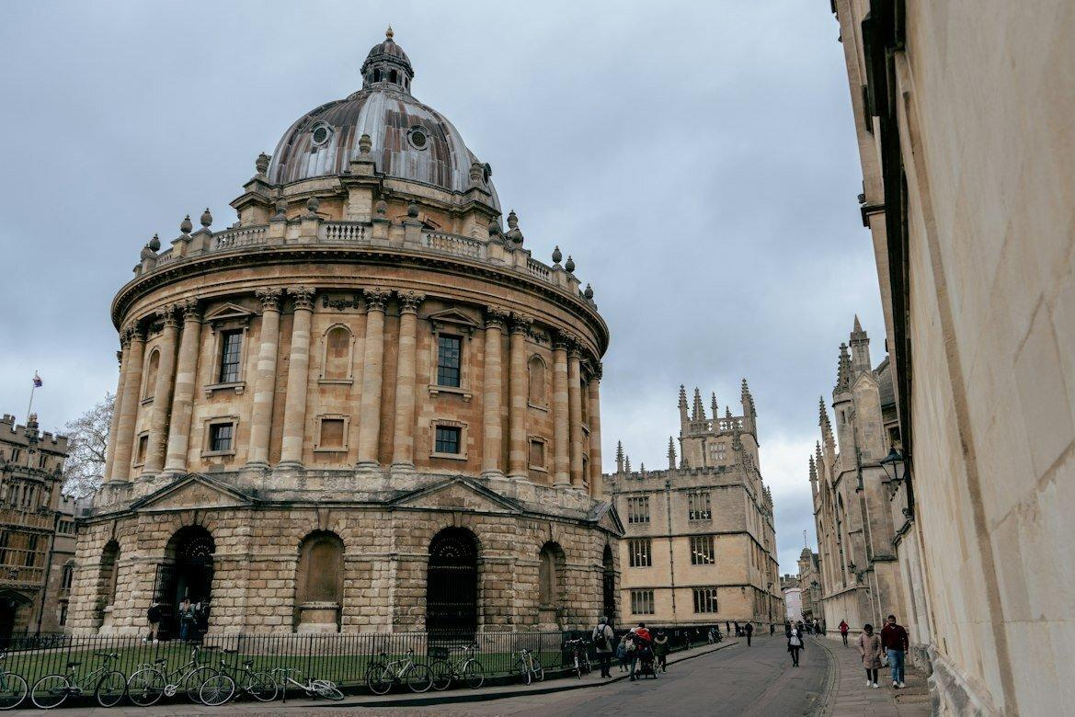
Oxford University in the U.K. Photo by Unsplash/Ben Elliott
This financial requirement is strictly for living costs and remains separate from tuition fees. Applicants must additionally demonstrate sufficient funds to cover any outstanding course fees for one academic year, as outlined in their Confirmation of Acceptance for Studies.
The Home Office links the maintenance requirement to the living-cost support available to domestic students through maintenance loans. This annual adjustment brings the figures in line with loan amounts for the 2026/27 academic year.
Students who have already paid for university accommodation can deduct that amount from their maintenance requirement. The maximum allowable deduction will also increase from £1,529 to £1,570.
Applicants must hold the required funds in an eligible bank account for at least 28 consecutive days. The final day of this 28-day period must fall within 31 days of the visa application date. For instance, an applicant applying on Jan. 1 must show the funds were held for 28 consecutive days ending no earlier than Dec. 1.
The requirement can also be met through qualifying student loans or official financial sponsorship.
Certain applicants are exempt from the financial requirement. This includes individuals applying as student union sabbatical officers and students who have lived in the U.K. on a valid visa for at least 12 months immediately preceding their application.
Students do not need to provide proof of funds if they are British nationals (overseas) or citizens of specific exempt countries and territories.
The exempt list includes Australia, Austria, Bahrain, Barbados, Belgium, Botswana, Brazil, Brunei, Bulgaria, Cambodia, Canada, Chile, China, Croatia, the Republic of Cyprus, Czechia, Denmark, the Dominican Republic, Estonia, Finland, France, Germany, Greece, Hong Kong, Hungary, Iceland, Indonesia, Ireland, Italy, Japan, Kazakhstan, Kuwait, Latvia, Liechtenstein, Lithuania, Luxembourg, Macao, Malaysia, Malta, Mauritius, Mexico, the Netherlands, New Zealand, Norway, Oman, Peru, Poland, Portugal, Qatar, Romania, Serbia, Singapore, Slovakia, Slovenia, South Korea, Spain, Sweden, Switzerland, Taiwan, Thailand, Tunisia, the United Arab Emirates, and the United States.
During the 2024/25 academic year, 685,565 international students were enrolled at U.K. higher education institutions, making up 24% of the total student population. Of these, 63,600 came from the EU and 622,000 from outside the bloc.
This total marks a 10% drop from the record high in 2022/23, representing the second consecutive year of decline. Since the current higher education sector was established in the early 1990s, international student numbers have fallen in only one other year, which was 2012/13.

